Ch.2 Lab 2 Exercises

# Task 1

Given the height and the radius of a right circular cone, calculate the surface area of the cone using this formula:

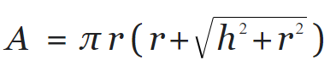

**Assume that the height (h) is 20 inches and the radius is 10 inches.**

**The output:**

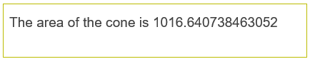

|  |
| --- |

|  |
| --- |

# 

# Task 2

Giving change. Implement a program that directs a cashier on how to give change. The program has two inputs: the amount due and the amount received from the customer. Display the dollars, quarters, dimes, nickels, and pennies that the customer should receive in return. In order to avoid roundoff errors, the program user should supply both amounts in pennies, for example, 274 instead of 2.74.

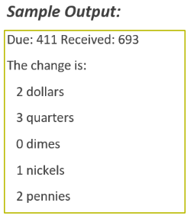

|  |
| --- |

|  |
| --- |

|  |
| --- |

# 

# 

# Task 3

Given a string, do the following:

•Print the length of the string

•Replace all lower case ‘a’ with upper case ‘A’ and print it

•Capitalize the whole string and print it.

•Print the second character

•Print the last character

•Print the middle character



  
  

  
  